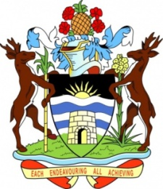

Ministry of Foreign Affairs,

Agriculture, Trade and Barbuda Affairs GOVERNMENT OF ANTIGUA AND BARBUDA

Press Release
Ministry of Foreign Affairs

The Government of Antigua and Barbuda remains deeply concerned that the Republic of Cuba remains on the US State Department’s list of countries that have been deemed to be state sponsors of terrorism.

The Government further notes that keeping Cuba on the State Sponsors of Terrorism (SSOT) list continues to cause severe hardship and suffering to the Cuban people and calls on the United States Government to immediately remove Cuba from that list.

Additionally, Antigua and Barbuda is aware that the economic, commercial and financial embargo imposed against Cuba, which took effect in 1960, still remains in place, and continues to have an adverse effect on the economic and social development of Cuba, and particularly, on the Cuban people, in light of crippling challenges, such as rising global inflation, and increases in food and fuel prices,

Since 1992, the United Nations General Assembly (UNGA) has annually voted in favour of resolutions regarding the need to put an end to the economic, commercial and financial embargo imposed against Cuba, and notes that the most recent resolution put forward by the UNGA on 2 November 2023, titled the “Necessity of ending the economic, commercial and financial embargo imposed by the United States of America against Cuba,” achieved near-universal consensus, underscoring the international community’s firm opposition to the embargo.

It is against this background that Antigua and Barbuda urges that both the designation as a state sponsor of terrorism and the 62-year-old embargo be terminated as a matter of urgency so that relief can be brought to the harsh conditions under which the Cuban people have had to endure.

