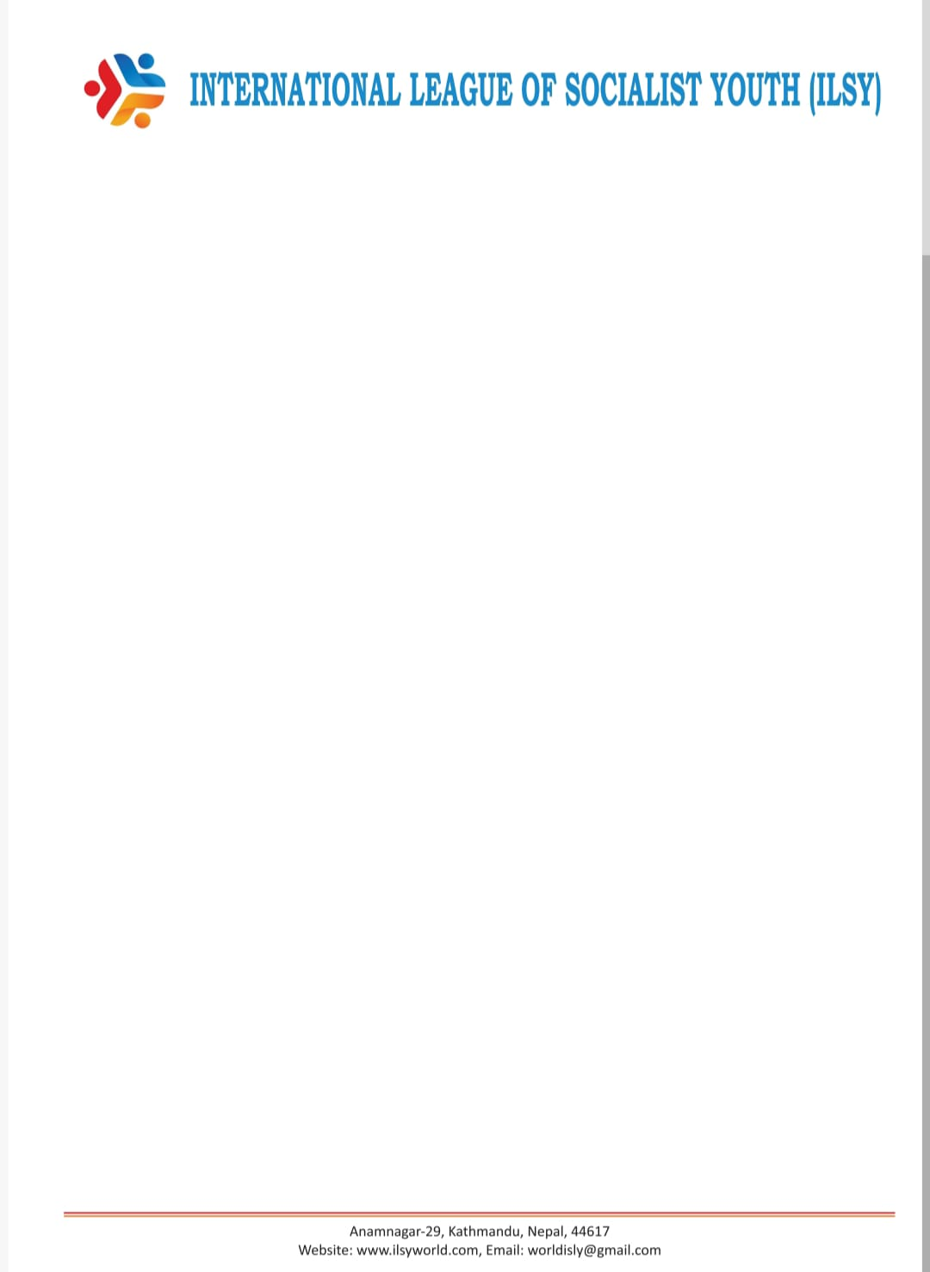
29th October 2025
Statement of the International League of Socialist Youth World about the US blockade and sanctions against Cuba.

The International League of Socialist Youth is vehemently condemning the repeated and ongoing immoral maneuvers of the US administration on various levels in order to aggravate the economic blockade and sanctions against the sovereign will of the Cuban people, who defend their right to determine their future and destiny without foreign and imperialist interference. The plans and actions of the USA are openly aiming at the asphyxiation of the brave Cuban people in order to achieve popular discontent against the Cuban Revolution. In addition to the blockade, lasting for more than six decades, the US administrations, regardless of who is leading them, are applying unilateral lists such as the one of “States Sponsoring Terrorism” in which Cuba is provocatively included.
The USA has never given up its plans for an overthrow of the Cuban Revolution by all means. Even the military intervention has never been ruled out, as it is visible these days with the open military aggression against Venezuela and the threats to invade the country.
The USA has a long record of such interventions and coups in the region. Today it is targeting particularly Cuba, Venezuela, Nicaragua, but also other countries of the region that do not agree with the “priorities” of the USA.
While approaching the vote at the General Assembly against the US blockade, special efforts and actions are being witnessed in order to exercise pressure on sovereign states for their vote in the UN General Assembly.
The ILSY denounces all these plans and expresses its firm and full-hearted solidarity and support to the Cuban people and its leadership. The USA and its allies have no moral authority to decide upon the future of Cuba and we demand the unconditional lifting of the criminal blockade and all other unilateral coercive measures against the island of the revolution.
We call upon the UN Member States to show their support to the founding principles of the UN founding Charter which has been continuously violated after 80 years of its adoption.
Sudip Sharma Adhikari
Coordinator - chief of international department ( ILSY)
sudip.sharma42@gmail.com

