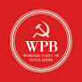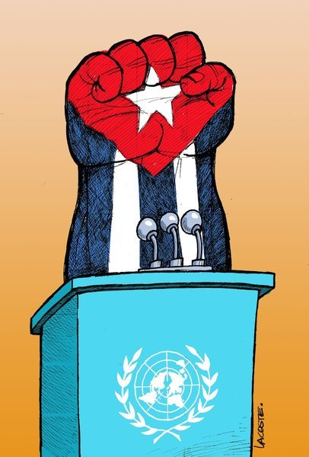

"Statement From Workers Party of Bangladesh"
In Solidarity with the People of Cuba and the UN Resolution for an End to the US Blockade

October 26, 2025

The Workers Party of Bangladesh stands in unwavering solidarity with the people and government of Cuba and strongly supports the draft resolution entitled "Necessity of putting an end to the economic, commercial and financial blockade imposed by the United States of America against Cuba," to be considered at the United Nations General Assembly on October 28th and 29th, 2025.

For over six decades, the Cuban people have endured the severe hardships inflicted by what is the most enduring trade embargo in modern history . This blockade is not a relic of the past; it is a continuous act of economic warfare that violates international law, the principles of the UN Charter, and the fundamental rights of an entire nation. The Workers Party of Bangladesh condemns this blockade in the strongest possible terms and joins the global chorus demanding its immediate and unconditional end.
The Illegitimacy of the Blockade and Its Human Cost

The US embargo against Cuba, first imposed in 1960 and intensified through laws like the Helms–Burton Act of 1996, represents a blatant attempt to suppress the sovereignty of a independent nation . Its stated goal has always been to force political change through collective punishment, targeting all sectors of the Cuban economy and causing immense suffering to ordinary citizens . This policy has been overwhelmingly rejected by the international community, with the UN General Assembly consistently voting—year after year—to condemn it. The near-unanimous support for this resolution is a testament to its fundamental injustice.

Condemnation of Coercive Diplomacy

The Workers Party of Bangladesh views with grave concern the reports that the US government has, once again, deployed an intense campaign of pressure, targeting sovereign nations to vote against the Cuban resolution . Such tactics of blackmail, threats, and coercion have no place in the halls of the United Nations. They undermine the very principle of sovereign equality among states and disrespect the rigxplicitly threatened to punish countries for their votes, with former officials infamously putting delegations "on notice" and vowing to take names of those who opposed its position . We call on all nations to resist this pressure and to vote according to the dictates of international law and conscience, not out of fear of retribution.

A Call for a Just Vote and a New Chapter

From October 27th until the moment of the vote, social movements, political parties, and peace-loving people across the globe will stand with Cuba. The Workers Party of Bangladesh is proud to count itself among them. We urge every member state of the United Nations General Assembly to:

1. Vote in FAVOUR of the draft resolution to end the US economic, commercial, and financial blockade against Cuba.
2. Reject all forms of external pressure and coercion and uphold the sovereign right of all states to determine their own diplomatic relations.
3. Send a clear message that unilateral coercive measures have no place in the 21st century and that dialogue and cooperation must replace hostility and punishment.

The continuation of this blockade is a moral and political failure. Its end is long overdue. The Workers Party of Bangladesh believes that a vote for this resolution is a vote for justice, for multilateralism, and for the right of all peoples to self-determination and development.

End the Blockade Now!
Long Live International Solidarity!

On Behalf of the Workers Party of Bangladesh,

Nur Ahmed Bakul,
General Secretary ( In Charge)

