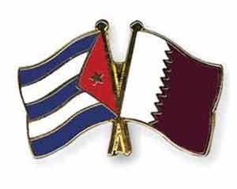
Embajada de Cuba en Catar

PRESS RELEASE

The Embassy of the Republic of Cuba would like to express its most sincere gratitude to all friends in Qatar who have extended their condolences and solidarity to this Embassy and to the Government and people of Cuba on the occasion of the passing away of Commander in Chief Fidel Castro Ruz.
Doha, 6 December, 2016

