**CUBA IN IBEROAMERICAN FILM SHOWS IN ZIMBABWE.**

 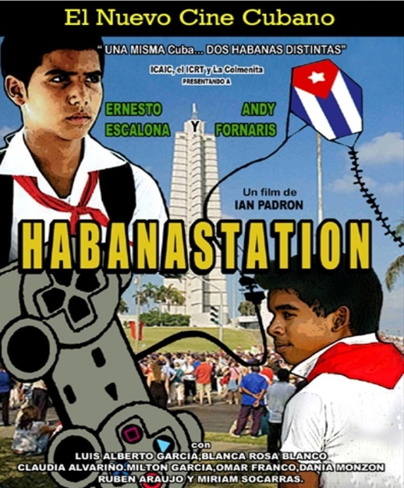

Zimbabwe, September 30, 2016 - Cuba was present in an Iberoamerican film show that took place in Harare, Zimbabwe, with the purpose of bringing the culture and art of Iberoamerican countries to the Zimbabwean public.

The event, which took place during the week from 26 to 30 September, was organized by the embassies of Brazil, Cuba, Spain, Portugal and Argentina, the latter as concurrent for attending Zimbabwe from South Africa, and had the collaboration of Alliance Francaise of Harare. 5 films representing each participating country were shown.

For Cuba was selected **Habanastation**, film produced in 2011 and directed by Ian Padron. The Charge d'Affaires a.i. of Cuba in Harare, the 3rd Secretary Vladimir Guerra Diaz, represented the Cuban Embassy during the film show.

**(Cubaminrex-Embacuba Zimbabwe)**