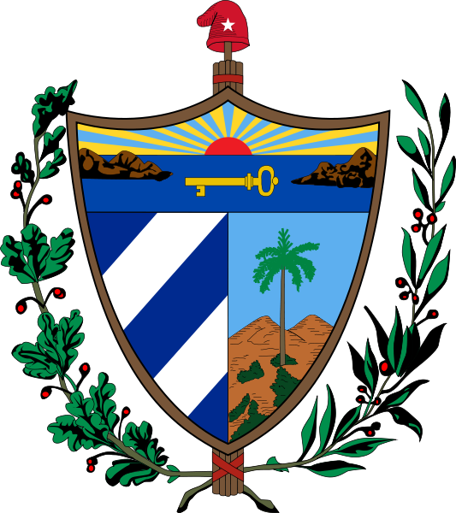
CONSULADO GENERAL DE LA REPÚBLICA DE CUBA EN ROTTERDAM, REINO DE LOS PAÍSES BAJOS
APPLICATION FORM FOR TOURIST CARD
NAME (as your passport) _______________________________________________ LAST NAME: ________________________
CITIZENSHIP (Nationality): ___________________ COUNTRY OF BIRTH: _______________
PASSPORT NUMBER: ______________________ DATE OF BIRTH: ____/____/____
Day Month Year
ADDRESS (HOLLAND): ________________________________________________________ POSTAL CODE: ____________
CITY: _______________________________ CONTACT TELEPHONE (HOLLAND):________________________________
E-mail:______________________________________________________________
DATE OF ENTRY TO CUBA: _____________ DATE OF DEPARTURE FROM CUBA: ___________ TOTAL LENGTH OF STAY: _____DAYS

I am aware of the following:
- A tourist card is valid only for leisure or recreational purposes. It is not valid for other travel purposes.
- It is valid for a 30-day stay in Cuba, extendable in Cuba for another 30 days (60 days maximum).
- Once a tourist card has been issued it cannot be changed or refunded.
- Claims will be only accepted until 48 hours, on working days, before the flight date to Cuba.
DATE: ___/___/____ SIGNATURE: __________________________________
Day Month Year
(If you cut out the information below, we will assume you have read it and agree with it)

MAIN INFORMATION

Opening Hours: Monday to Friday from 9:00 a.m to 1:00 pm E-mail: concuba@bart.nl
Phone: (31-10) 206-7334 (attention to the public by phone: 2 to 3 pm) Web: http://misiones.minrex.gob.cu/es/paisesbajos
Addres: Groot Handelsgebouw, Conradstraat 18 (Floor E-7, Office 154), 3013 AP, Rotterdam
If you apply in person, the tourist card will be handed out in the moment (Previous appointment is not necessary):
- Tourist card (Tourist visa) Fee: 22.00 Euros by previous bank transference only. When applying, you must submit:
- The form above; filled and signed.
- Your passport (which must be valid for the entire journey until your return to Holland)
- If your passport is not from EU, you have to submit a photocopy of your Dutch residence or at least a Visa valid for 6 months after departure from Cuba.
- Confirmation of travel arrangements (Flight ticket/reservation/booking with the date Cuba entry and departure).
- If you are travelling with your friends or family, you can apply for them too. The non-personal procedures cost an extra 25.00 Euros per person (children under 18 years old do not pay the extra fee).

For several days now there have been problems when making payments through the PIN terminal installed in our Consulate. Through no fault of our own these issues are likely to persist until further notice. All efforts will be made to resolve this situation, despite of the fact that it does not depend on the Embassy or the Consulate. In order to mitigate this inconvenience as much as possible, prevent any misunderstanding and provide quality and expedite service to the best of our ability the following steps must be taken before coming to the consulate in person:
- Use the email concuba@bart.nl to receive information as to the total amount to be paid for the services you require. You can consult the official web site of the Cuban Embassy to check the consular services fees at: http://misiones.minrex.gob.cu/es/paisesbajos
2. Make a bank transfer for the above mentioned service to the following bank account cuenta bancaria:
NAME OF THE BANK: Rabobank
NAME OF THE ACCOUNTHOLDER (BENEFICIARY): Embajada de Cuba
ACCOUNTNUMBER: 1224.21.434
IBAN: NL05 RABO 0122 4214 34
BIC: RABONL2U
3. Wait for a reasonable amount of time, a minimum of 24 hours to check with the Consulate if the transfer was completed, if so you may go to the Consulate to receive the service.
Other ways methods of payment are being currently assessed. We will keep you informed.
Citizens of the Netherlands, or other nationalities, travelling to Cuba from the United States or using U.S. airlines; the organization selling the ticket to the United States will also sell the Tourist Card to enter Cuba and will provide the affidavit that all passengers, American or not, travelling to Cuba from the U.S. or using U.S. airlines, should fill.
If you need to apply by post, you have to send us by e-mail (concuba@bart.nl) in (.pdf):
- legible photocopy of your passport, legible confirmation of travel arrangements and the form above, filled for each one.
- the pay is only for bank transfer (in that case, you have to ask us by email the information necessary for sending the transfer). When a transfer is placed, please notify the Consulate about this.
- The transfer should be made for the exact amount, not one euro more or less. If the transfer is made for less of the required quantity, the service will not be rendered until complete it. If the transfer is made for more than the needed quantity, the account office of the embassy would have to do the procedure to return the exceeding quantity.
The return of the exceeding quantity will only be done in case the information of the amount to transfer was not accurately provided by the Consulate or in case of a double transfer by the client. In any case, it should be understood that returning the exceeding quantity entails a complex bureaucratic process with costs to the Account Office of the Embassy.
- Payment an extra consular fee of $ 25.00 euros will be charged for non personal service and 9.00 euros (Netherlands) 15.00 euros (in Europe) 17.00 euros (out of Europe) by postage in order to return the documents.

PARA USO DEL CONSULADO | TT número: ______________ | Fecha expedición: __/__/___

